Testing report of chip LAN9514 on Koruza V1.1

|  |  |
| --- | --- |
|  |  |
|  |  |

Author: Tadej Plej

Maribor, 19. April 2021

Table of contents

Problem description 1

Used equipment 1

Checking every power supply pin 2

Working device 2

Broken device 18

Checking ethernet signals 34

Working device 34

Broken device 36

Checking clock signals on 25 MHz oscillator 37

Working device 37

Broken device 39

**List of pictures**

Picture 1: Testing setup 1

Picture 2: Pin 5: VDD33A – DC 2

Picture 3: Pin 5: VDD33A - AC 2

Picture 4: Pin 10: VDD3A – DC 3

Picture 5: Pin 10: VDD3A – AC 3

Picture 6: Pin 15: VDD18CORE – DC 4

Picture 7: Pin 15: VDD18CORE - AC 4

Picture 8: Pin 19: VDD33IO -DC 5

Picture 9: Pin 19: VDD33IO – AC 5

Picture 10. Pin 27: VCC33IO - DC 6

Picture 11: Pin 27: VCC33IO - AC 6

Picture 12: Pin 33: VDD33IO -DC 7

Picture 13: Pin 33: VDD33IO - AC 7

Picture 14: Pin 38: VDD18CORE - DC 8

Picture 15: Pin 38: VDD18CORE - AC 8

Picture 16: Pin 39: VDD33IO - DC 9

Picture 17: Pin 39: VDD33IO - AC 9

Picture 18: Pin 46: VDD33IO - DC 10

Picture 19: Pin 46: VDD33IO - AC 10

Picture 20: Pin 48: VDD18ETHPLL - DC 11

Picture 21: Pin 48: VDD18ETHPLL - AC 11

Picture 22: Pin 49: VDD33A - DC 12

Picture 23: Pin 49: VDD33A - AC 12

Picture 24: Pin 51: VDD33A - DC 13

Picture 25: Pin 51: VDD33A - AC 13

Picture 26: Pin 54: VDD33A - DC 14

Picture 27: Pin 54: VDD33A - AC 14

Picture 28: Pin 57: VDD33A - DC 15

Picture 29: Pin 57: VDD33A - AC 15

Picture 30: Pin 62: VDD18USBPLL - DC 16

Picture 31: Pin 62: VDD18USBPLL - AC 16

Picture 32: Pin 64: VDD33A - DC 17

Picture 33: Pin 64: VDD33A - AC 17

Picture 34: Pin 5: VDD33A - DC 18

Picture 35: Pin 5: VDD33A - AC 18

Picture 36: Pin 10: VDD3A - DC 19

Picture 37: Pin 10: VDD3A - AC 19

Picture 38: Pin 15: VDD18CORE - DC 20

Picture 39: Pin 15: VDD18CORE - AC 20

Picture 40: Pin 19: VDD33IO - DC 21

Picture 41: Pin 19: VDD33IO - AC 21

Picture 42: Pin 27: VCC33IO - DC 22

Picture 43: Pin 27: VCC33IO - AC 22

Picture 44: Pin 33: VDD33IO - DC 23

Picture 45: Pin 33: VDD33IO - AC 23

Picture 46: Pin 38: VDD18CORE - DC 24

Picture 47: Pin 38: VDD18CORE - AC 24

Picture 48: Pin 39: VDD33IO - DC 25

Picture 49: Pin 39: VDD33IO - AC 25

Picture 50: Pin 46: VDD33IO - DC 26

Picture 51: Pin 46: VDD33IO - AC 26

Picture 52: Pin 48: VDD18ETHPLL - DC 27

Picture 53: Pin 48: VDD18ETHPLL - AC 27

Picture 54: Pin 49: VDD33A - DC 28

Picture 55: Pin 49: VDD33A - AC 28

Picture 56: Pin 51: VDD33A - DC 29

Picture 57: Pin 51: VDD33A - AC 29

Picture 58: Pin 54: VDD33A - DC 30

Picture 59: Pin 54: VDD33A - AC 30

Picture 60: Pin 57: VDD33A - DC 31

Picture 61: Pin 57: VDD33A - AC 31

Picture 62: Pin 62: VDD18USBPLL - DC 32

Picture 63: Pin 62: VDD18USBPLL - AC 32

Picture 64: Pin 64: VDD33A - DC 33

Picture 65: Pin 64: VDD33A - AC 33

Picture 66: Schematic print of measuring points of differential pair for Ethernet 34

Picture 67: Differential pair TXP-TXN 34

Picture 68: Differential pair RXP-RXN 35

Picture 69: Differential pair TXP-TXN 36

Picture 70: Differential pair RXP-RXN 36

Picture 71: Schematic print of TCXO 37

Picture 72: XO 37

Picture 73: XI 38

Picture 74: XI signal with some spikes 38

Picture 75: XO 39

Picture 76: XI 39

Problem description

We have our custom PCB with chip LAN9514 which works for some time, but then stops working for an unknown reason (LEDs on the ethernet connector stops blinking, they’re turned on all the time).

Questions from Microchip Technical Support to be answered:

1. Have you check the power supplies at every power supply pin? ( Please pay particular attention to the VDD18CORE and VDD18ETHPLL pins). Could you scope the signals and attach them to the case please?

2. Are you using any power management features on the device?

3. When the link disappears, and there is slow blinking of the LED, are there any signals on RXP/M, TXP/M? Could you scope those signals and attach them to the case? Is there a link between one USB port and another? ( I am trying to see if this is a device-wide failure, or specific to the Ethernet part of the device, I am thinking it is the Ethernet part, but just to confirm)

4. Could you please check the clock when this is happening - is there any change to the clock when the problem occurs? Again, it would be helpful if you could scope the clock pins XI and XO and attach them to the case.

Used equipment

Oscilloscope: OWON MSO8202T

Oscilloscope: SIGLENT SDS 1102CML

POE: UBIQUITI NETWORKS HP-H240-125G

Custom PCB with Microchip LAN9514 chipset

Setup used for testing:

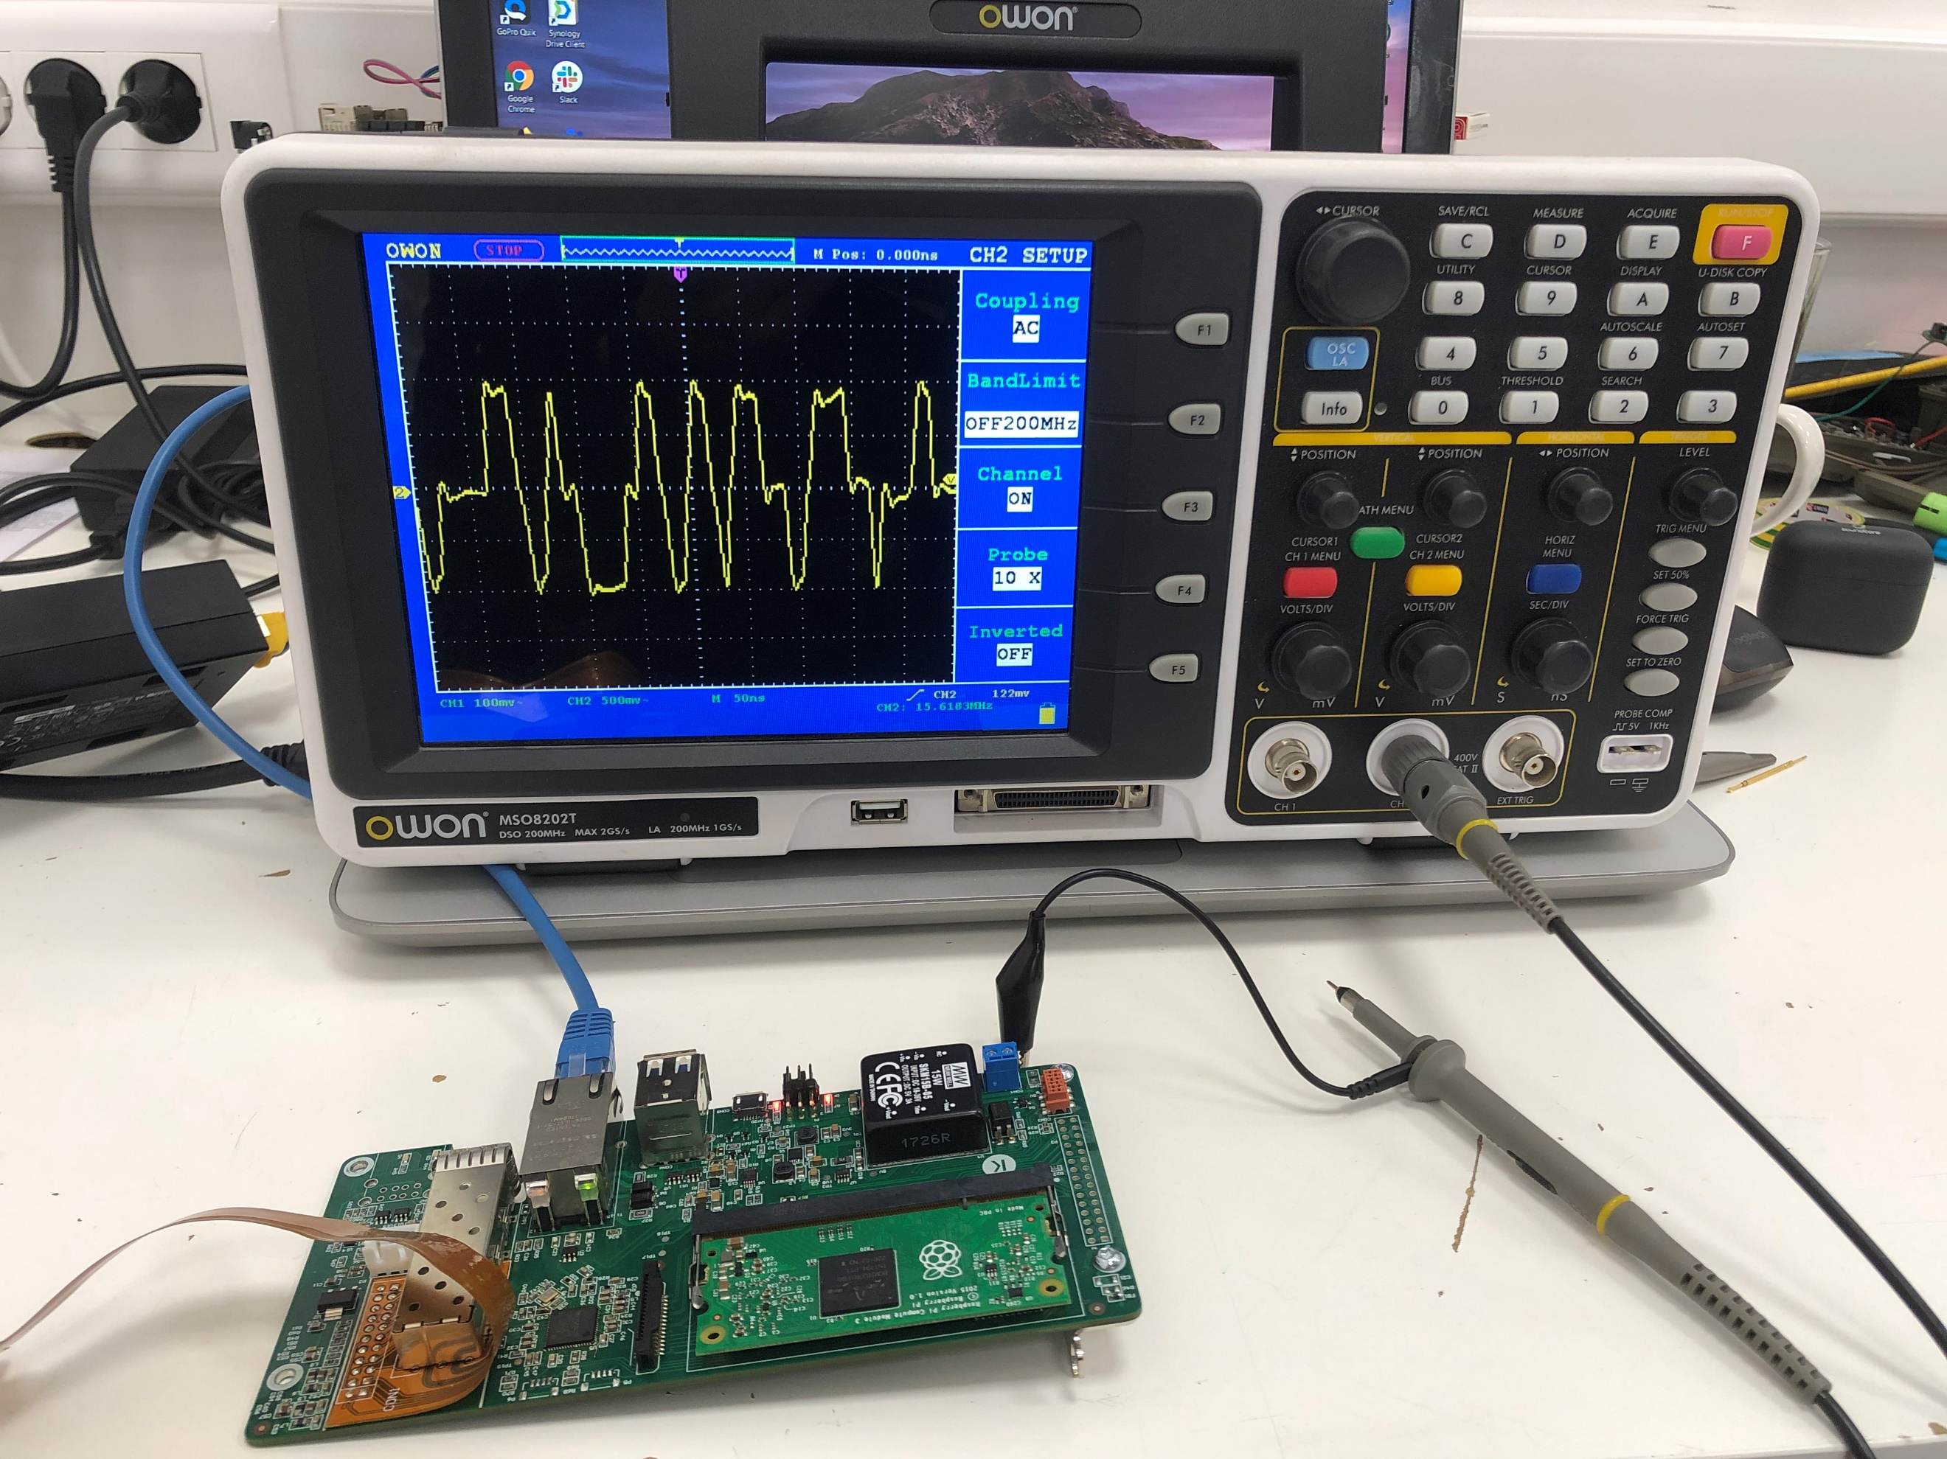

Picture : Testing setup

**NOTE: The shift in images with measurements is due to plotting of the graph on oscilloscope.**

Checking every power supply pin

Working device

**Pin 5: VDD33A**

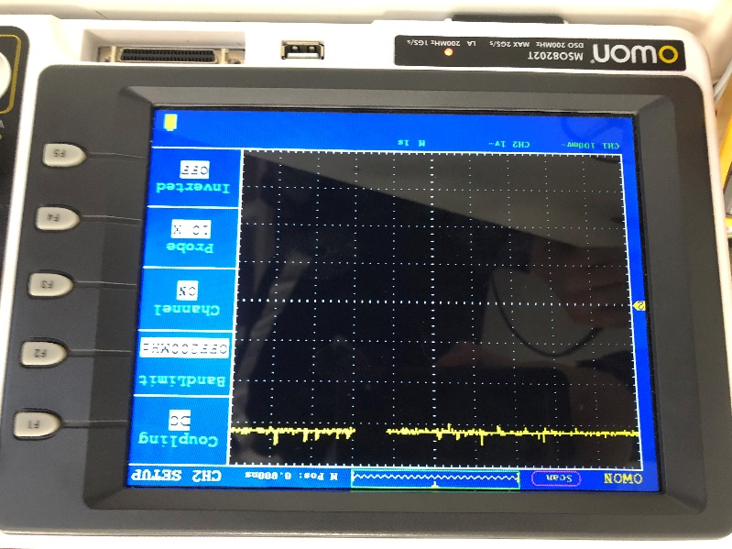

Picture : Pin 5: VDD33A – DC

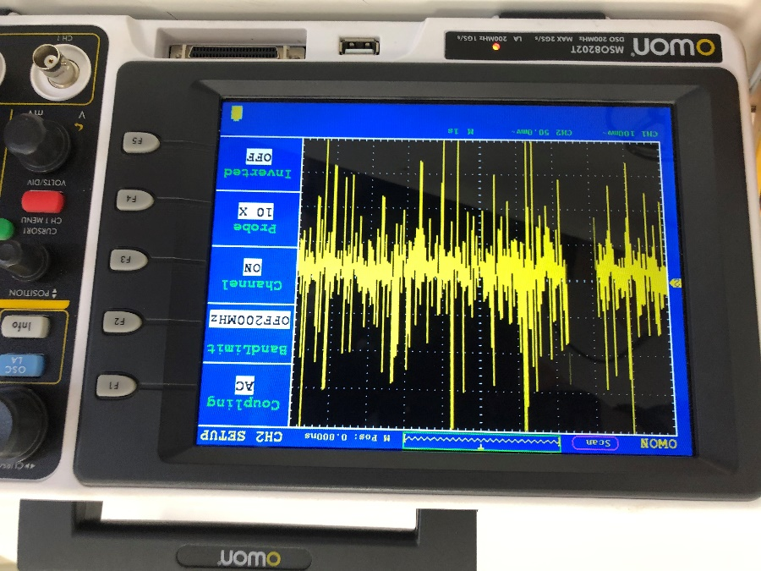

Picture : Pin 5: VDD33A - AC

**Pin 10: VDD3A**

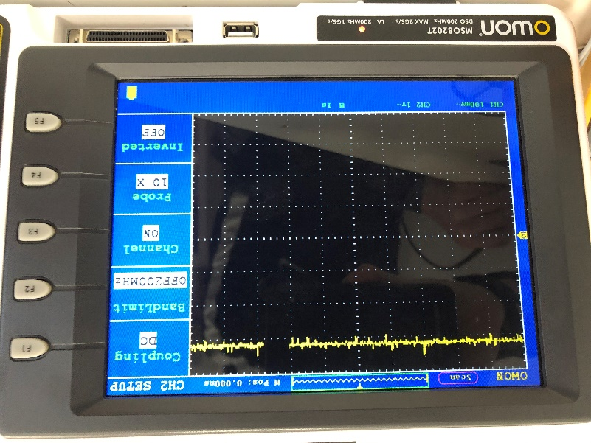

Picture : Pin 10: VDD3A – DC

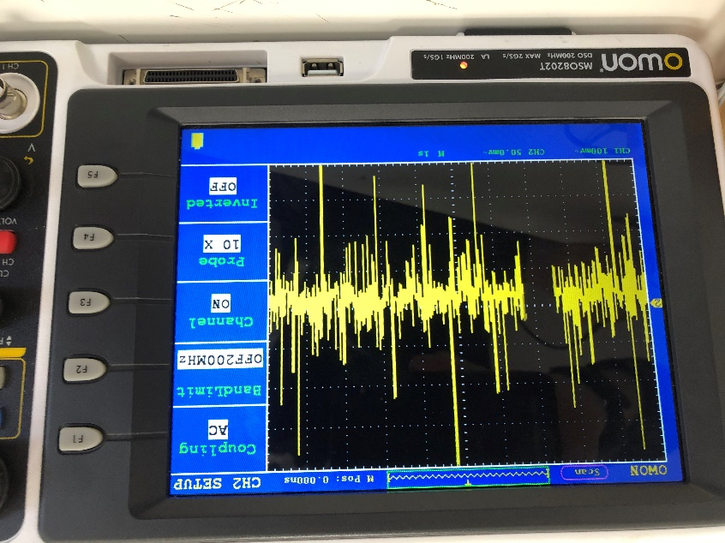

Picture : Pin 10: VDD3A – AC

**Pin 15: VDD18CORE**

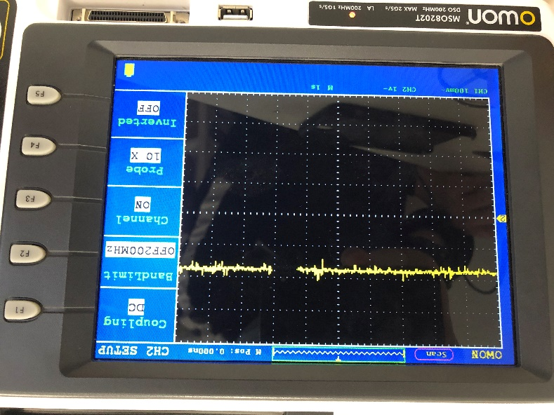

Picture : Pin 15: VDD18CORE – DC

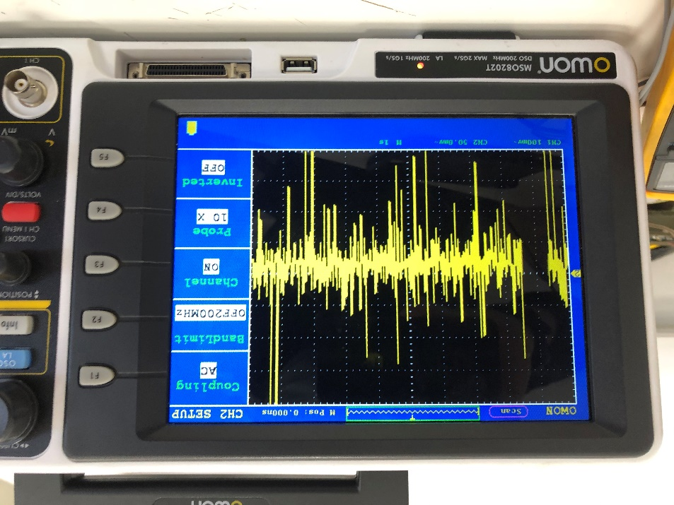

Picture : Pin 15: VDD18CORE - AC

**Pin 19: VDD33IO**

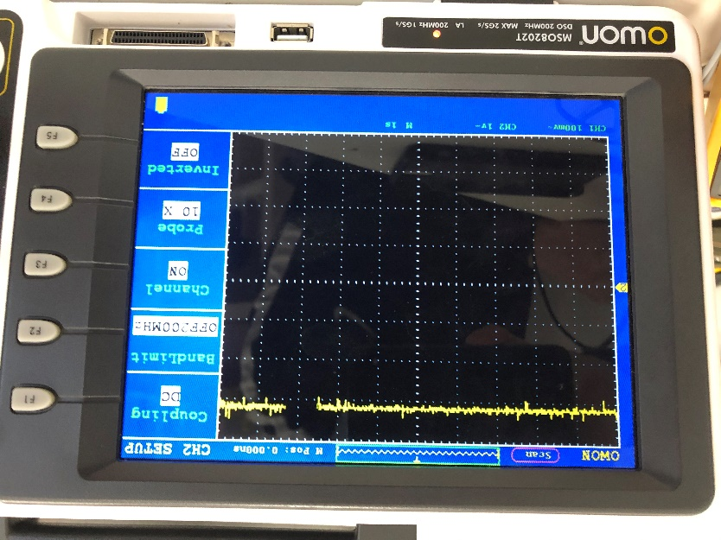

Picture : Pin 19: VDD33IO -DC

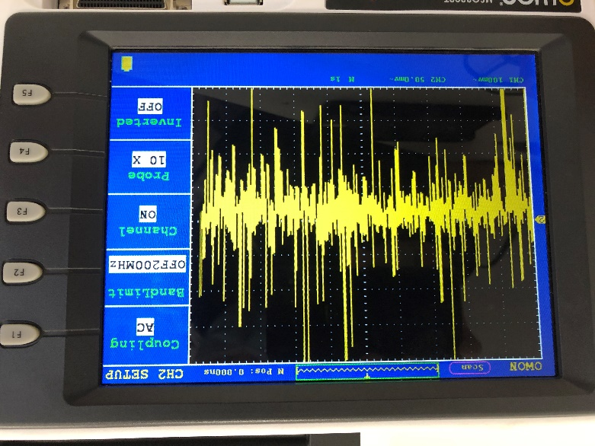

Picture : Pin 19: VDD33IO – AC

**Pin 27: VCC33IO**

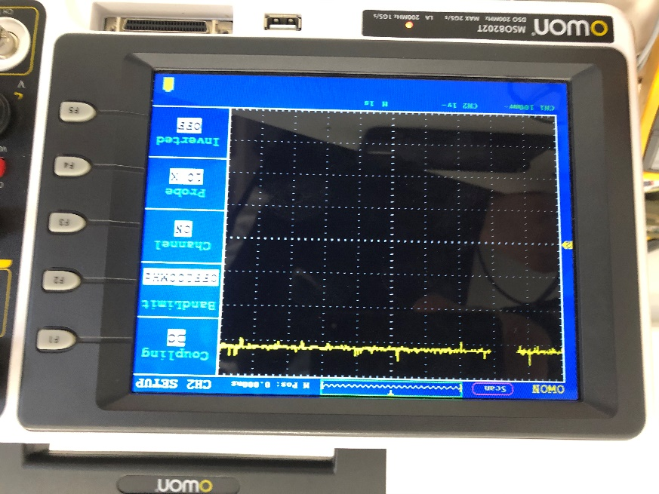

Picture . Pin 27: VCC33IO - DC

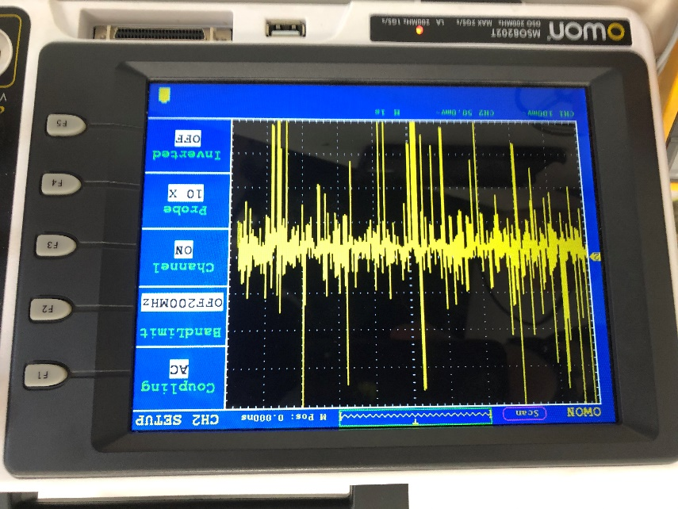

Picture : Pin 27: VCC33IO - AC

**Pin 33: VDD33IO**

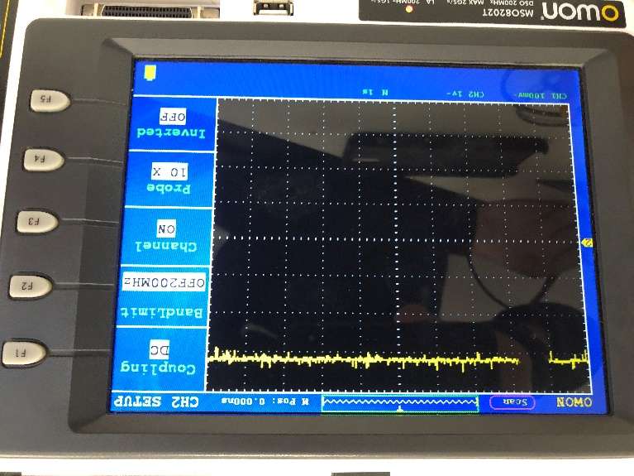

Picture : Pin 33: VDD33IO -DC

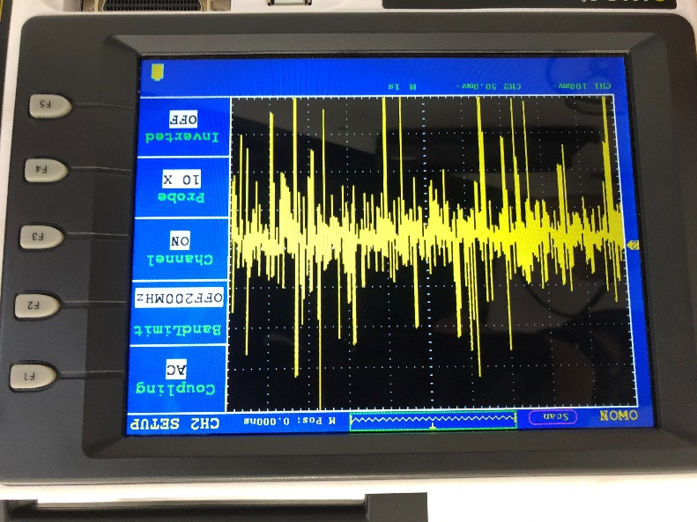

Picture : Pin 33: VDD33IO - AC

**Pin 38: VDD18CORE**

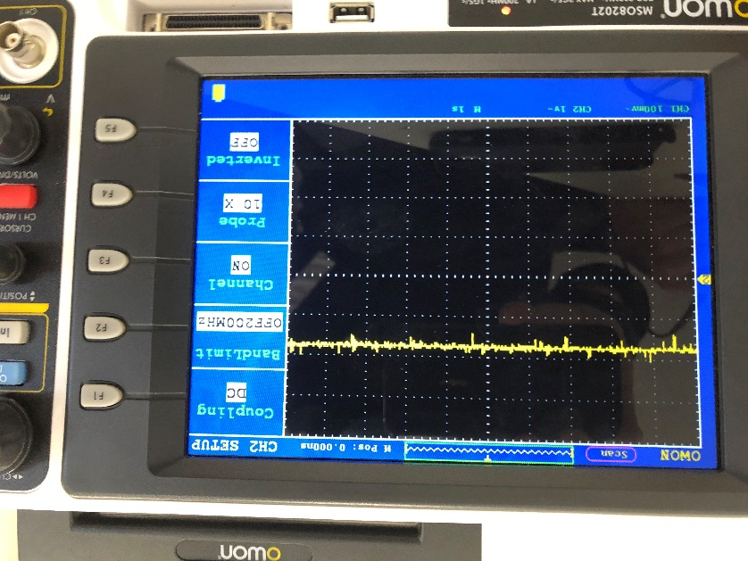

Picture : Pin 38: VDD18CORE - DC

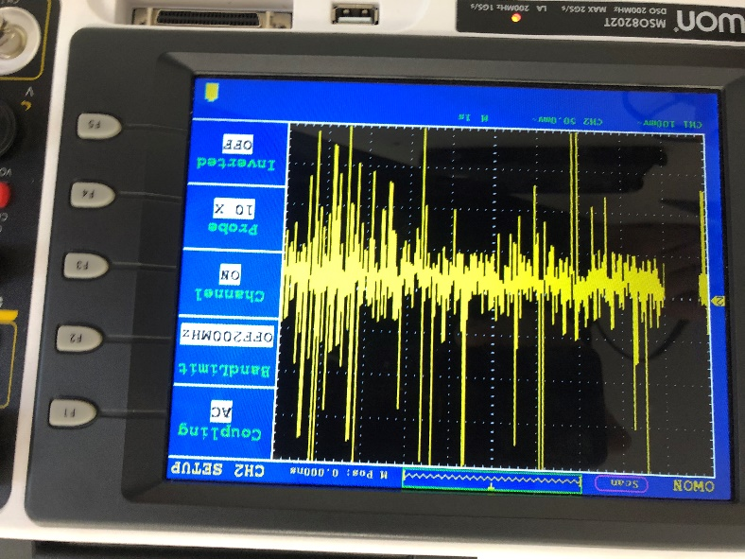

Picture : Pin 38: VDD18CORE - AC

**Pin 39: VDD33IO**

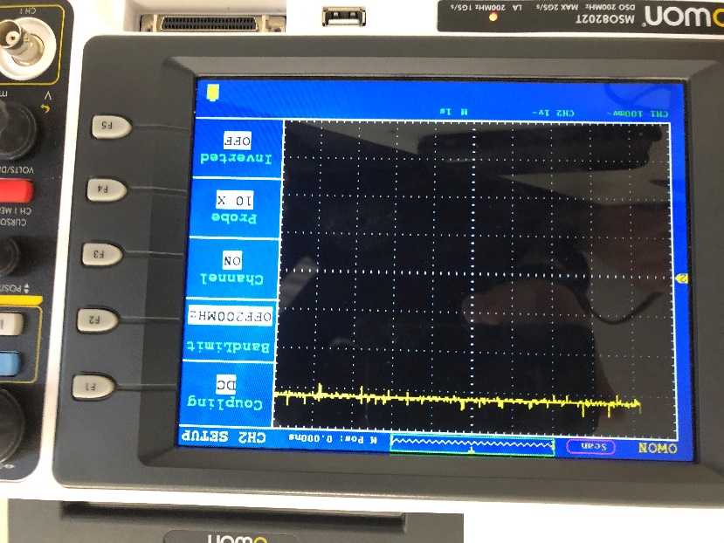

Picture : Pin 39: VDD33IO - DC

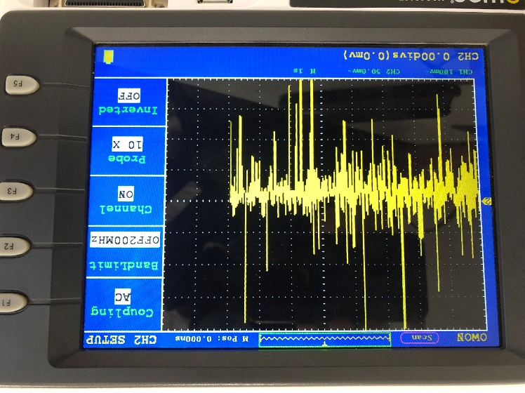

Picture : Pin 39: VDD33IO - AC

**Pin 46: VDD33IO**

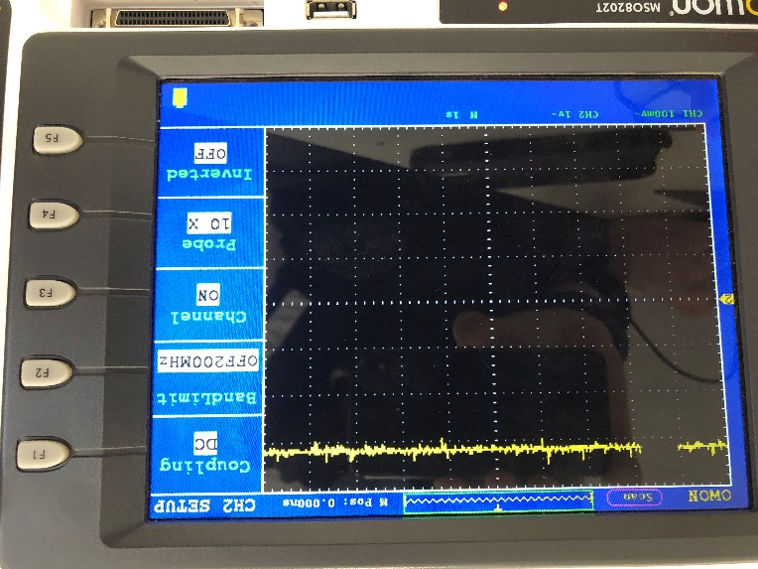

Picture : Pin 46: VDD33IO - DC

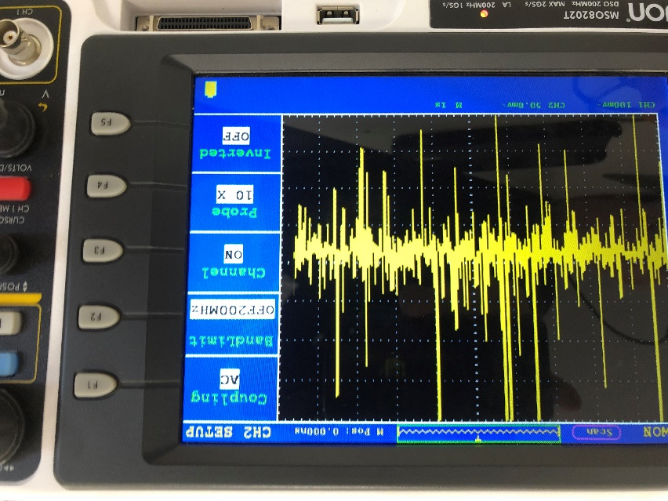

Picture : Pin 46: VDD33IO - AC

**Pin 48: VDD18ETHPLL**

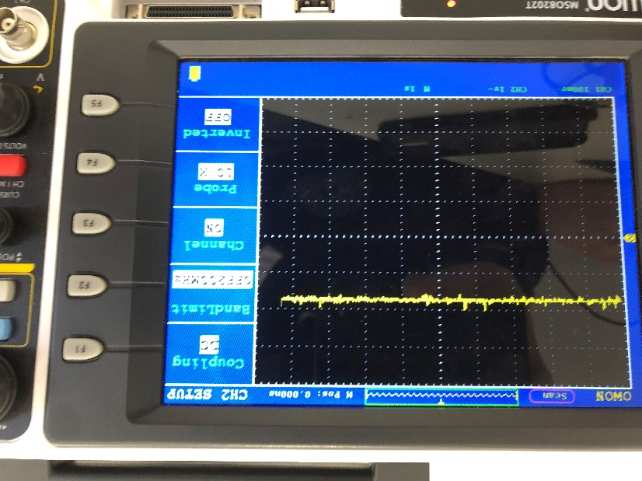

Picture : Pin 48: VDD18ETHPLL - DC

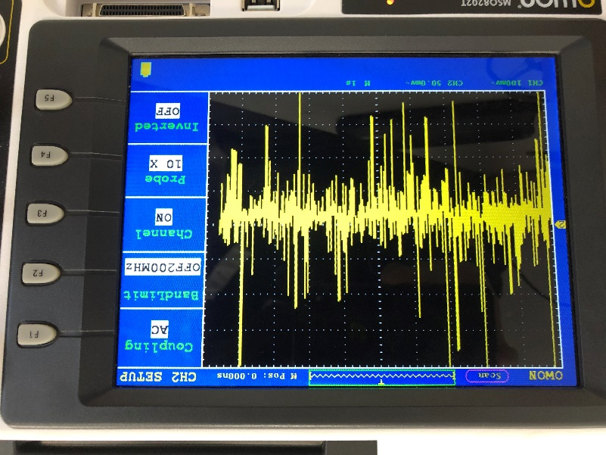

Picture : Pin 48: VDD18ETHPLL - AC

**Pin 49: VDD33A**

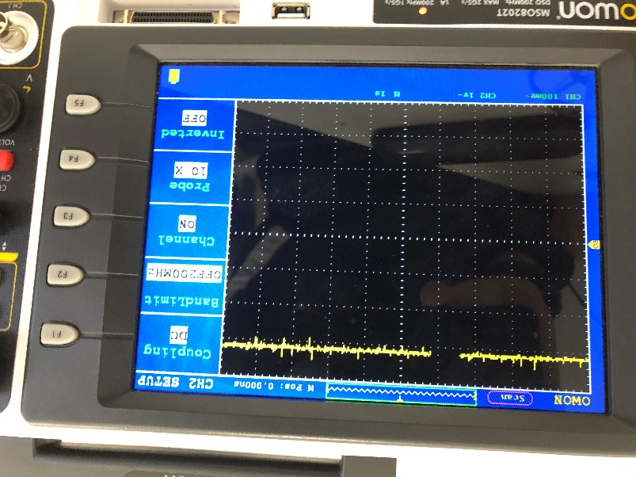

Picture : Pin 49: VDD33A - DC

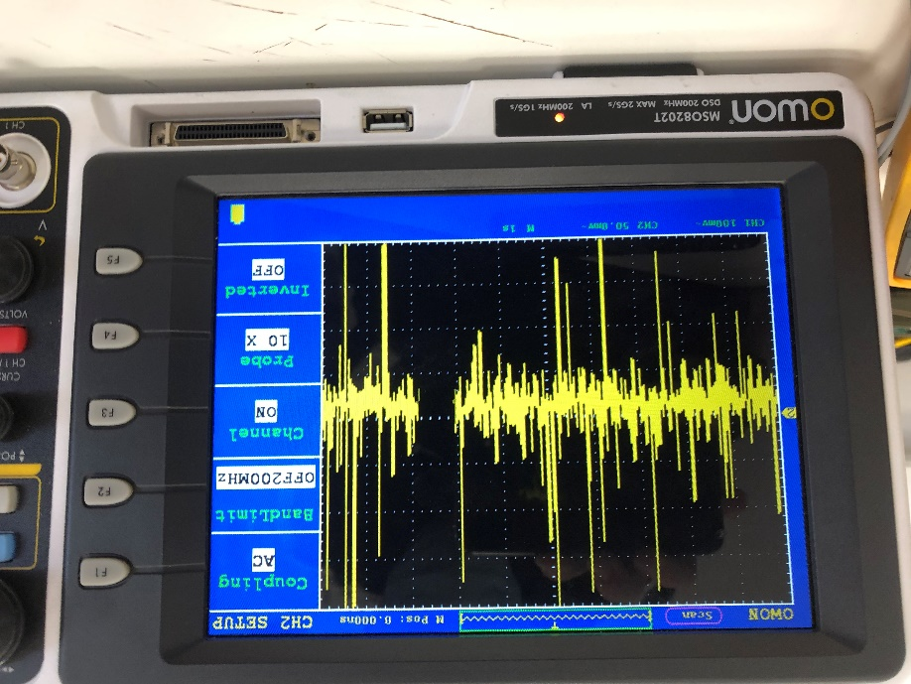

Picture : Pin 49: VDD33A - AC

**Pin 51: VDD33A**

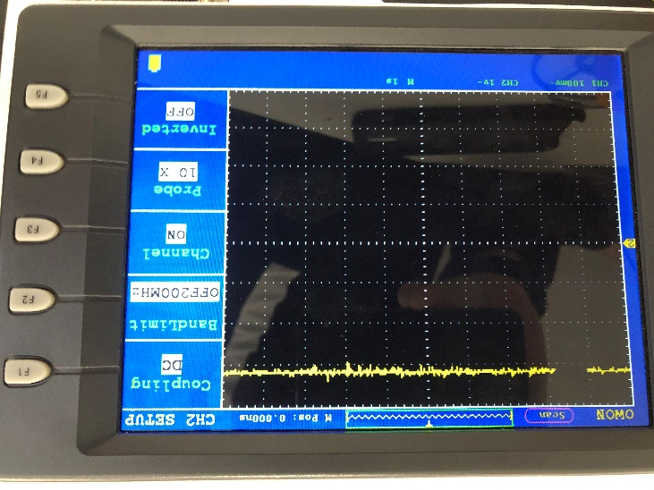

Picture : Pin 51: VDD33A - DC

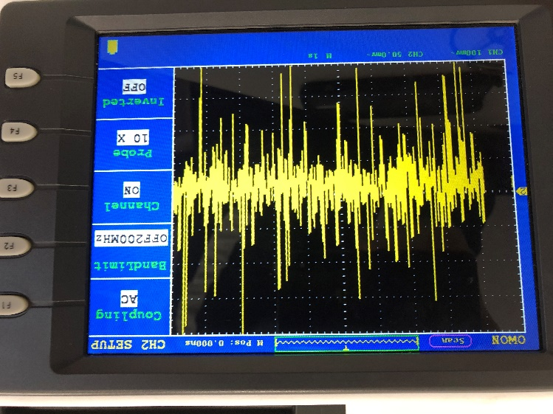

Picture : Pin 51: VDD33A - AC

**Pin 54: VDD33A**

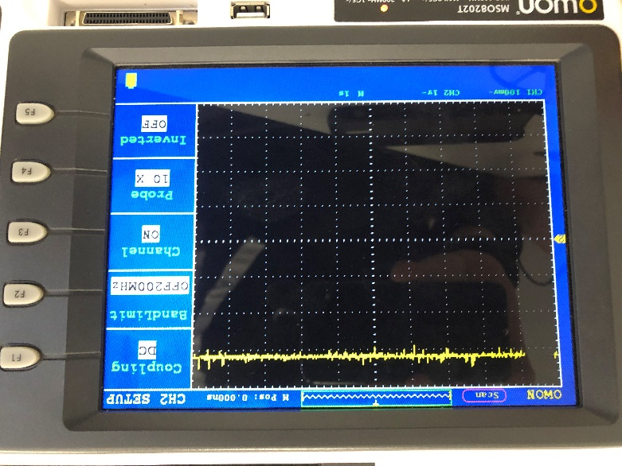

Picture : Pin 54: VDD33A - DC

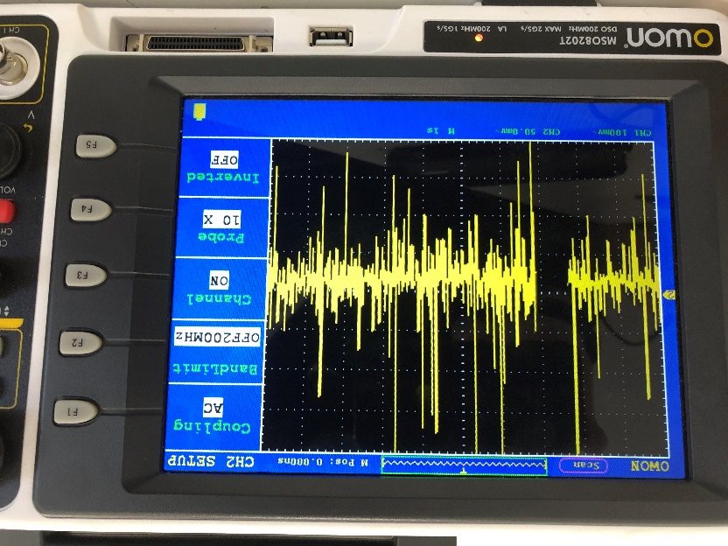

Picture : Pin 54: VDD33A - AC

**Pin 57: VDD33A**

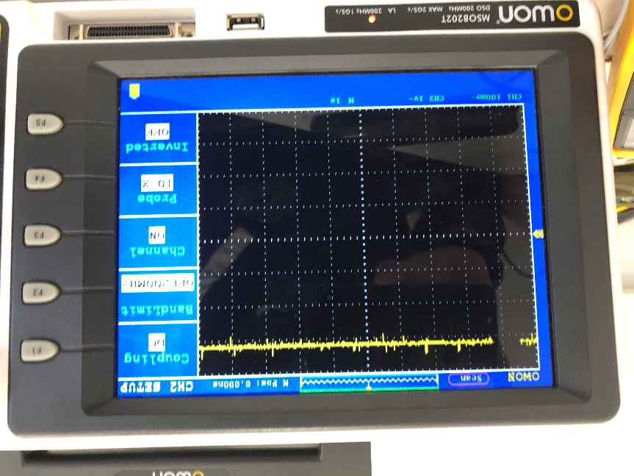

Picture : Pin 57: VDD33A - DC

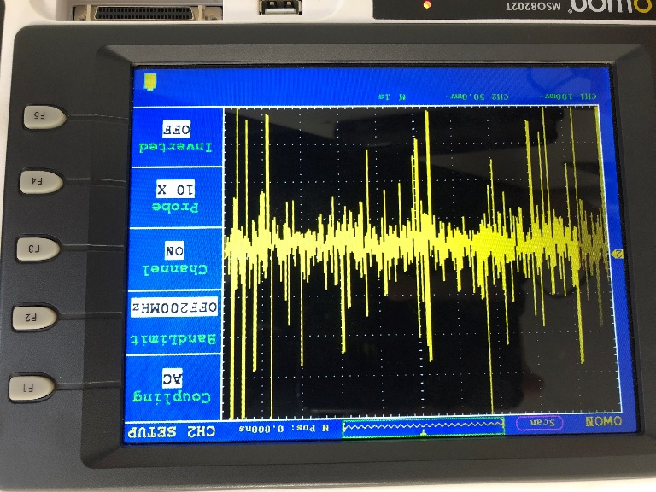

Picture : Pin 57: VDD33A - AC

**Pin 62: VDD18USBPLL**

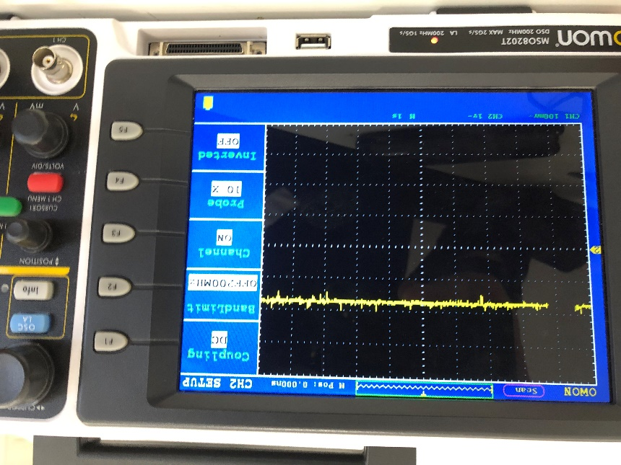

Picture : Pin 62: VDD18USBPLL - DC

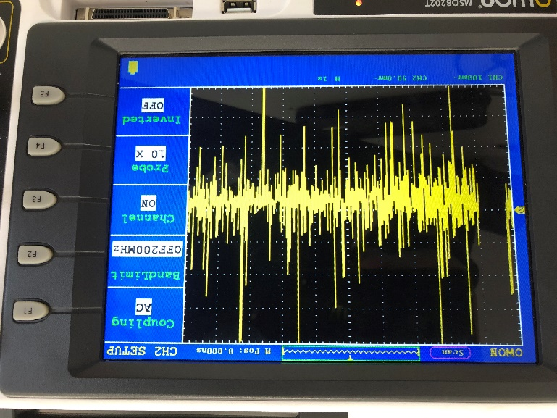

Picture : Pin 62: VDD18USBPLL - AC

**Pin 64: VDD33A**

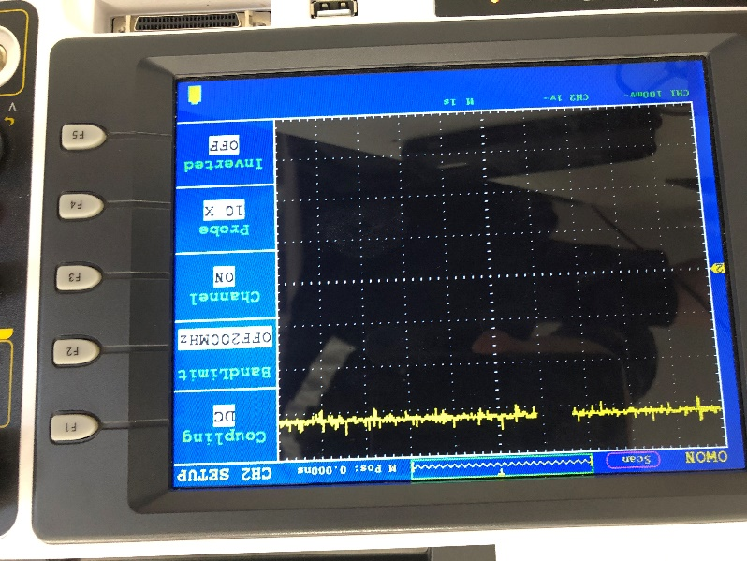

Picture : Pin 64: VDD33A - DC

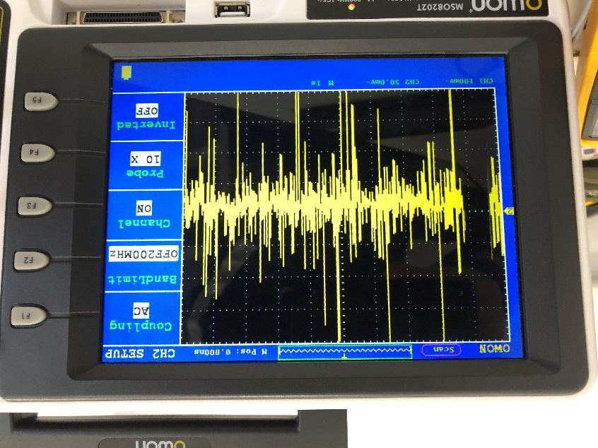

Picture : Pin 64: VDD33A - AC

Broken device

**Pin 5: VDD33A**

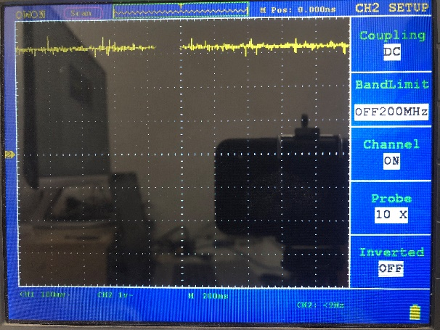

Picture : Pin 5: VDD33A - DC

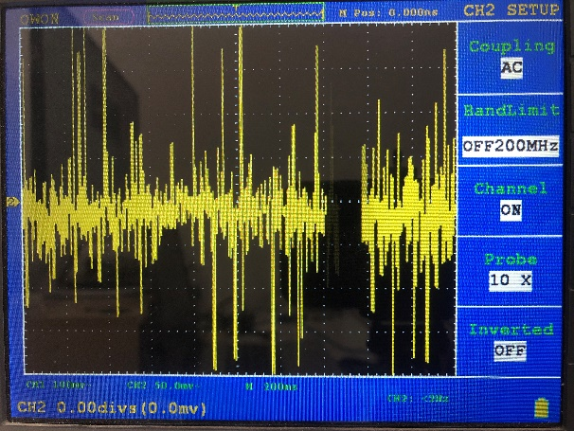

Picture : Pin 5: VDD33A - AC

**Pin 10: VDD3A**

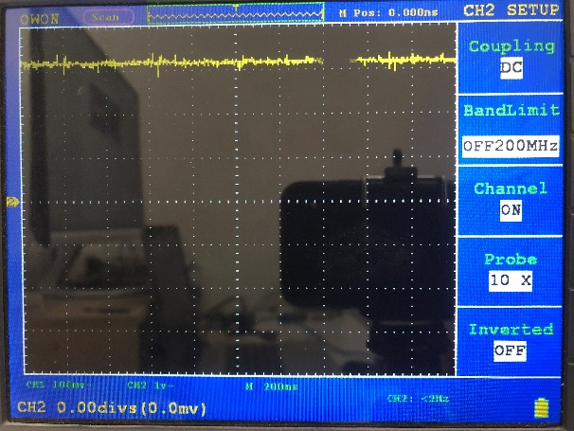

Picture : Pin 10: VDD3A - DC

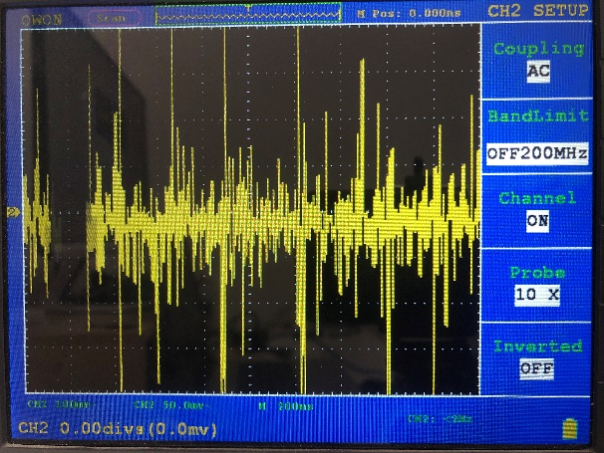

Picture : Pin 10: VDD3A - AC

**Pin 15: VDD18CORE**

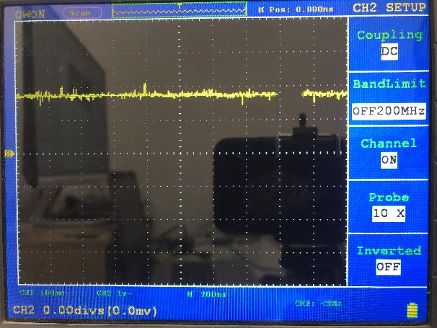

Picture : Pin 15: VDD18CORE - DC

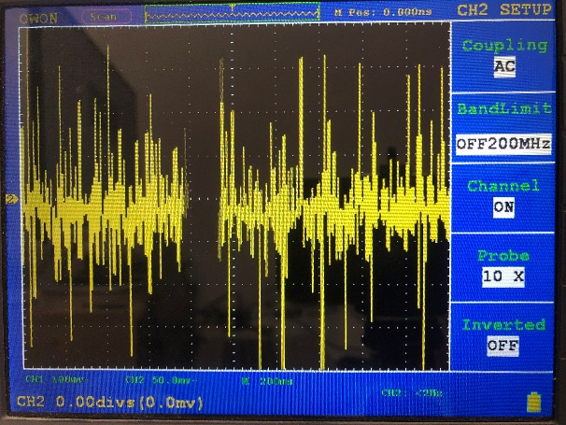

Picture : Pin 15: VDD18CORE - AC

**Pin 19: VDD33IO**

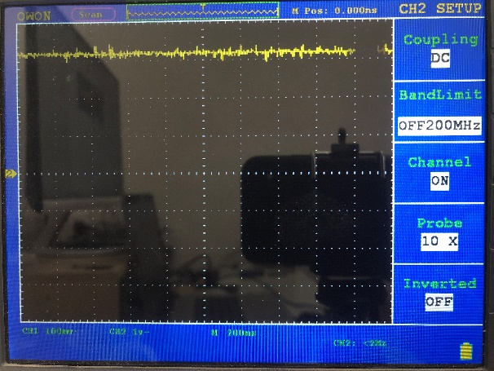

Picture : Pin 19: VDD33IO - DC

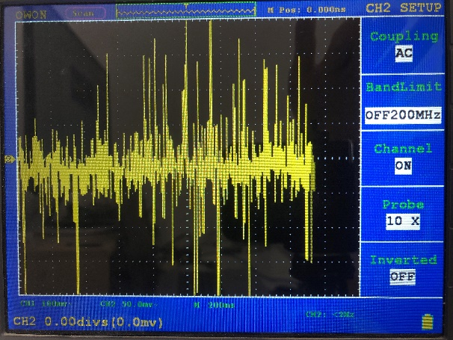

Picture : Pin 19: VDD33IO - AC

**Pin 27: VCC33IO**

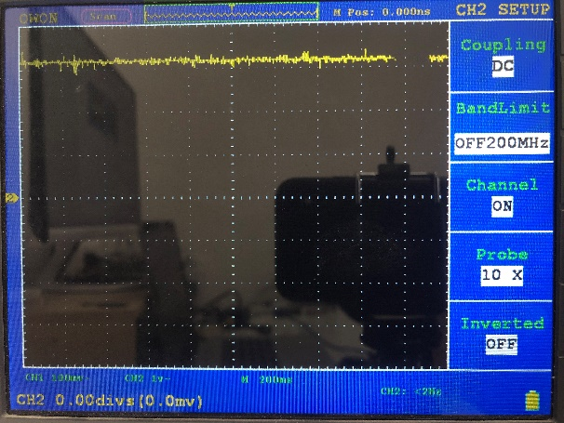

Picture : Pin 27: VCC33IO - DC

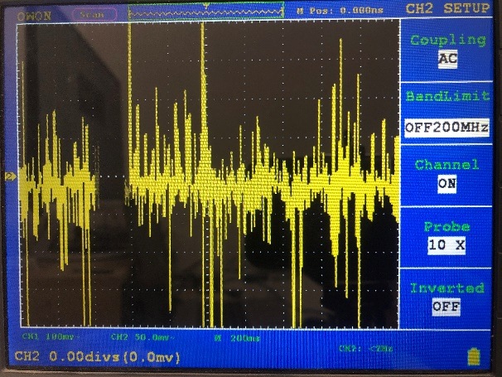

Picture : Pin 27: VCC33IO - AC

**Pin 33: VDD33IO**

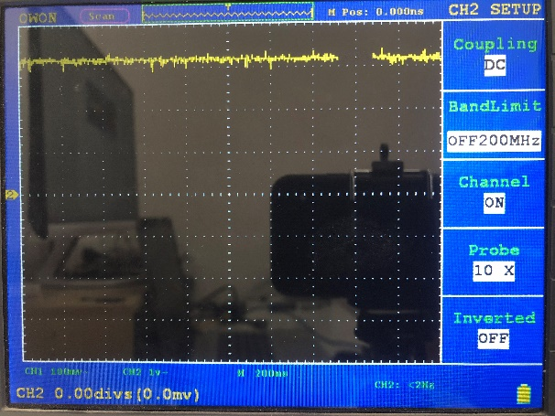

Picture : Pin 33: VDD33IO - DC

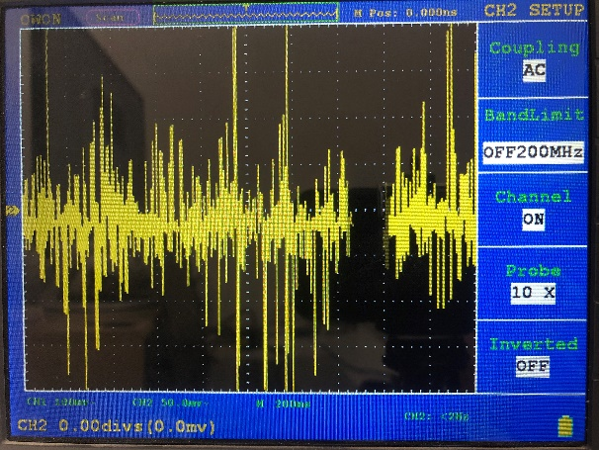

Picture : Pin 33: VDD33IO - AC

**Pin 38: VDD18CORE**

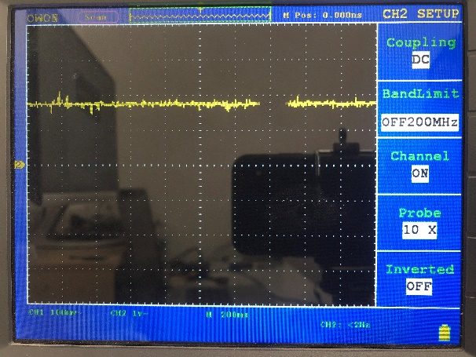

Picture : Pin 38: VDD18CORE - DC

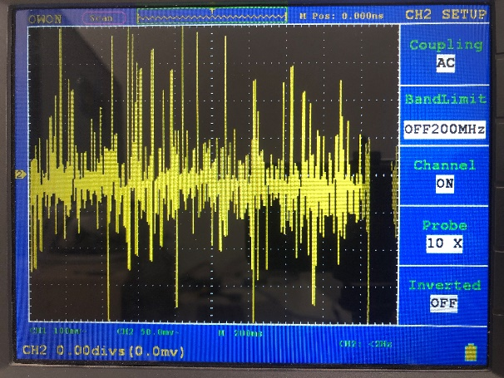

Picture : Pin 38: VDD18CORE - AC

**Pin 39: VDD33IO**

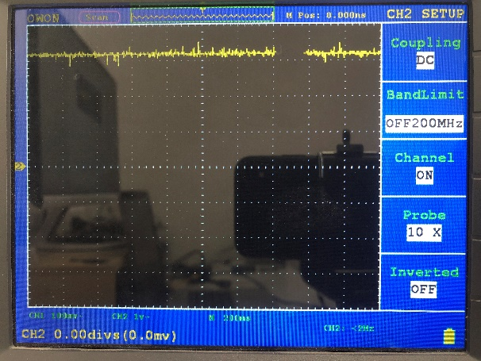

Picture : Pin 39: VDD33IO - DC

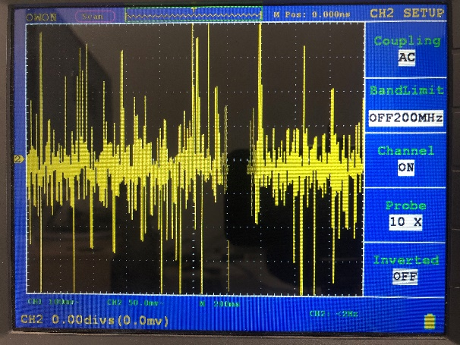

Picture : Pin 39: VDD33IO - AC

**Pin 46: VDD33IO**

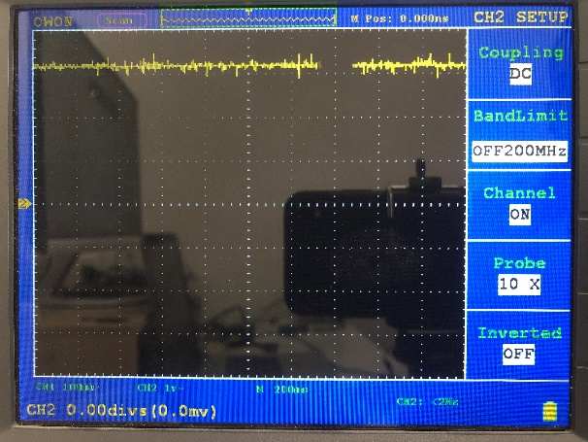

Picture : Pin 46: VDD33IO - DC

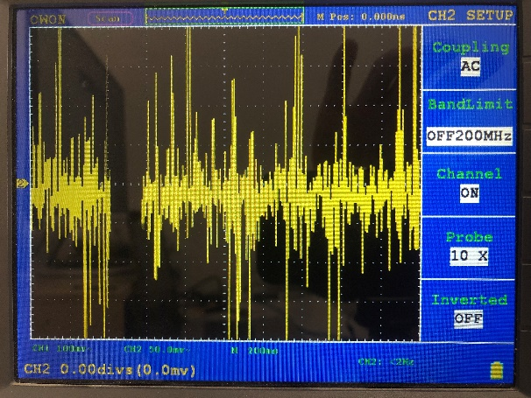

Picture : Pin 46: VDD33IO - AC

**Pin 48: VDD18ETHPLL**

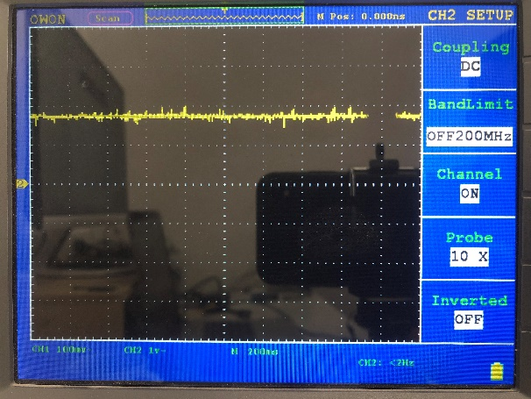

Picture : Pin 48: VDD18ETHPLL - DC

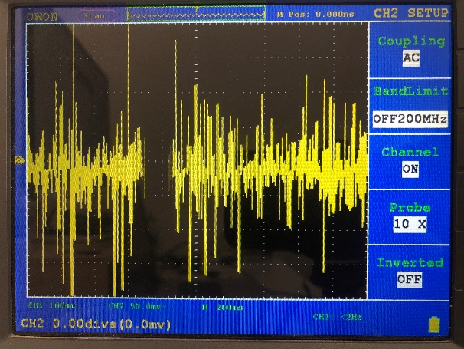

Picture : Pin 48: VDD18ETHPLL - AC

**Pin 49: VDD33A**

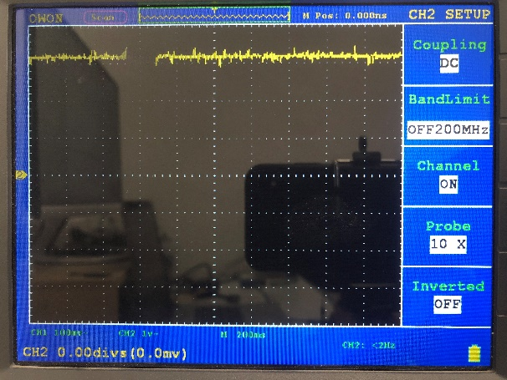

Picture : Pin 49: VDD33A - DC

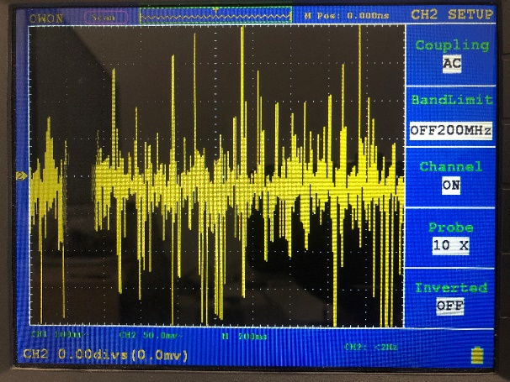

Picture : Pin 49: VDD33A - AC

**Pin 51: VDD33A**

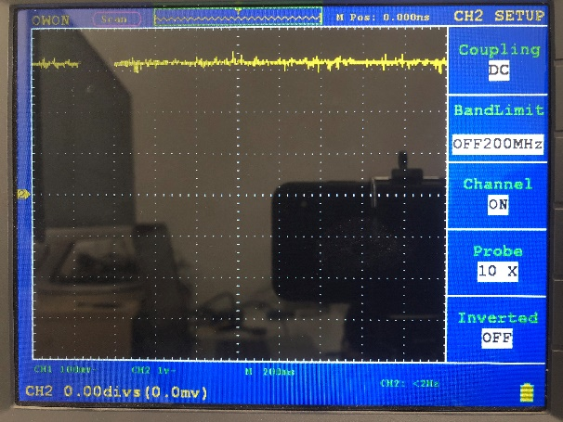

Picture : Pin 51: VDD33A - DC

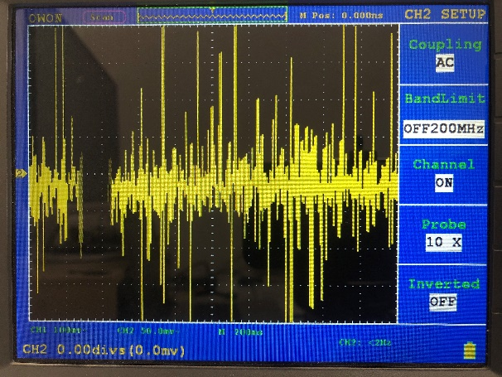

Picture : Pin 51: VDD33A - AC

**Pin 54: VDD33A**

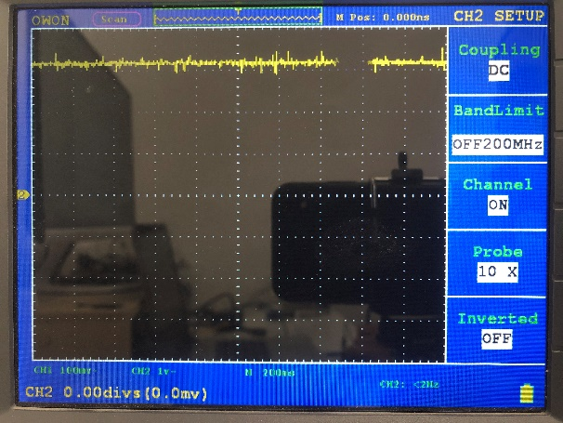

Picture : Pin 54: VDD33A - DC

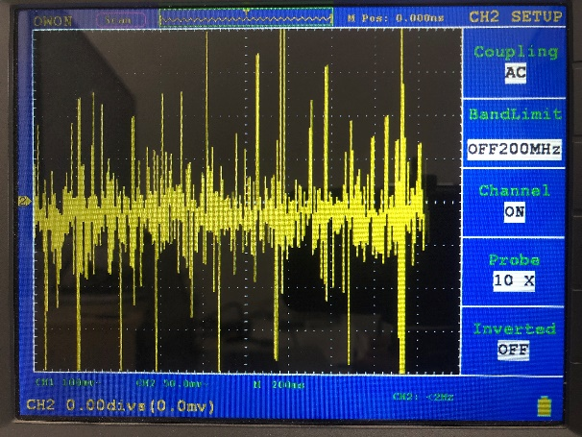

Picture : Pin 54: VDD33A - AC

**Pin 57: VDD33A**

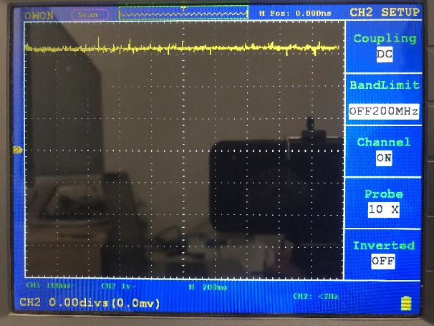

Picture : Pin 57: VDD33A - DC

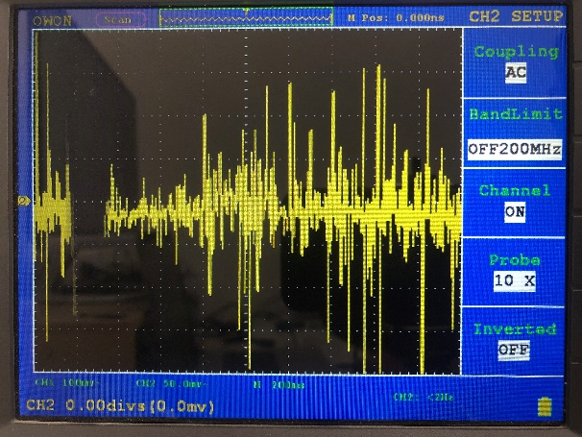

Picture : Pin 57: VDD33A - AC

**Pin 62: VDD18USBPLL**

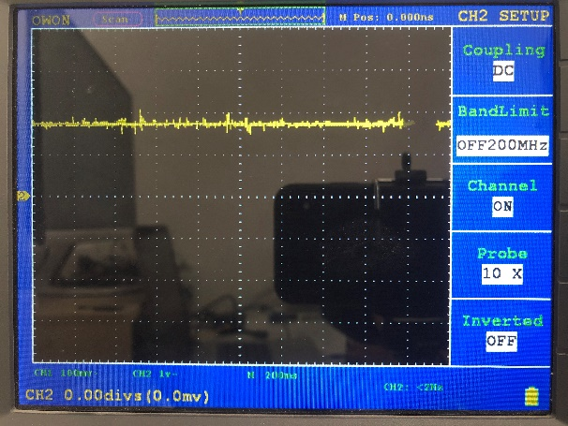

Picture : Pin 62: VDD18USBPLL - DC

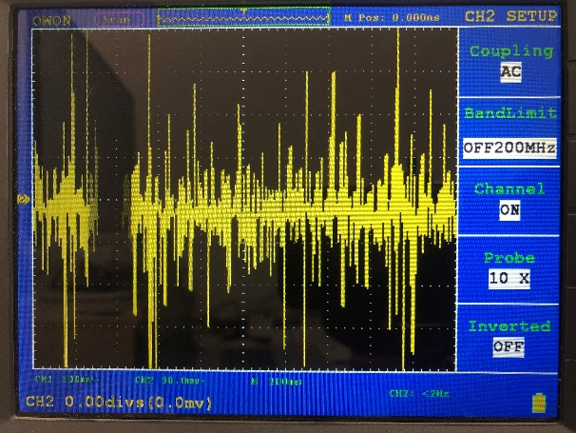

Picture : Pin 62: VDD18USBPLL - AC

**Pin 64: VDD33A**

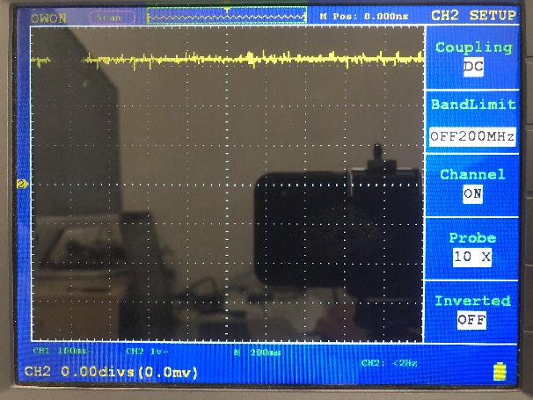

Picture : Pin 64: VDD33A - DC

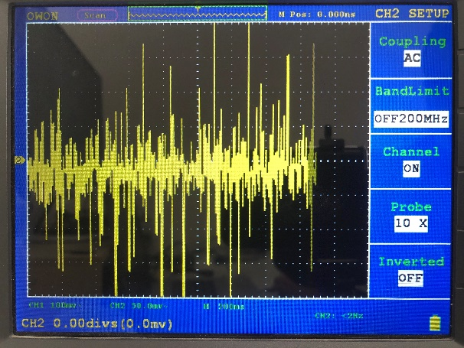

Picture : Pin 64: VDD33A - AC

Checking ethernet signals

Added schematic for a better understanding of measuring points.

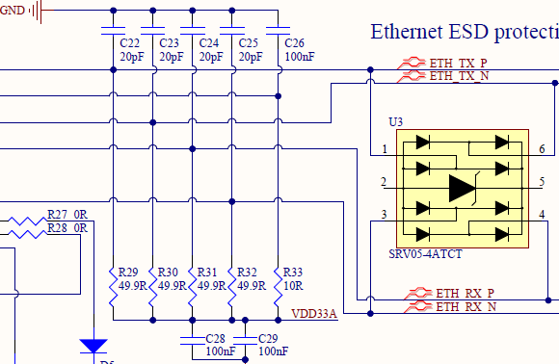

Picture : Schematic print of measuring points of differential pair for Ethernet

Working device

Measured a differential pair between R29 - TXP and R30 – TXN

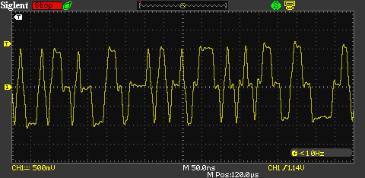

Picture : Differential pair TXP-TXN

Measured a differential pair between R31 - RXP and R32 –RXN

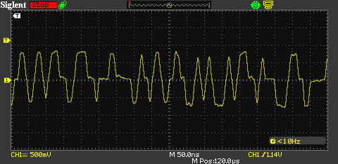

Picture : Differential pair RXP-RXN

Broken device

Measured a differential pair between R29 - TXP and R30 – TXN

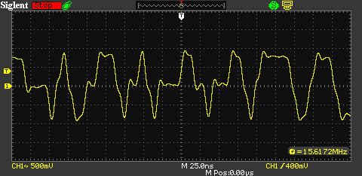

Picture : Differential pair TXP-TXN

Measured a differential pair between R31 - RXP and R32 –RXN

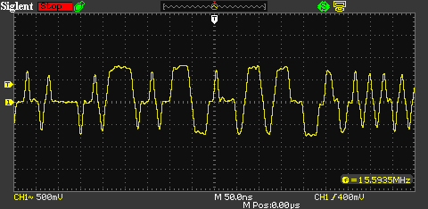

Picture : Differential pair RXP-RXN

Checking clock signals on 25 MHz oscillator

Added schematic for a better understanding of measuring points.

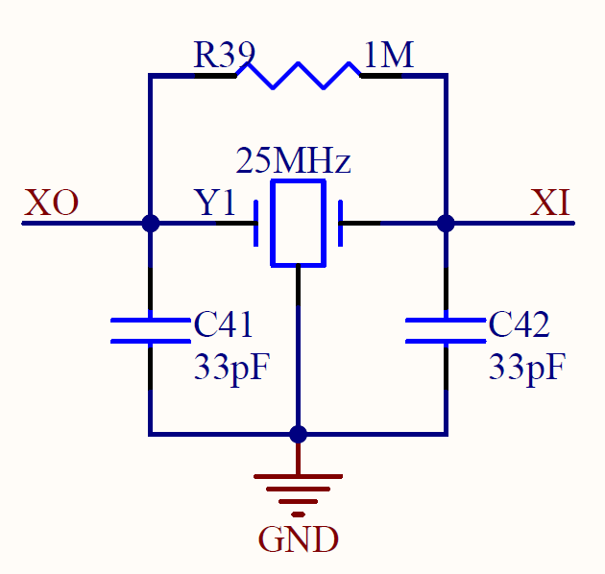

Picture : Schematic print of TCXO

Working device

XO measured on C41:

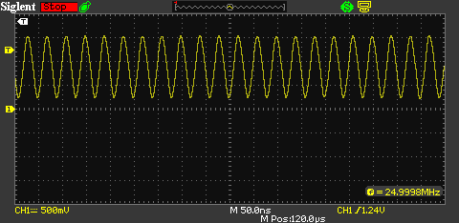

Picture : XO

XI measured on C42:

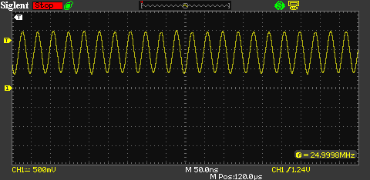

Picture : XI

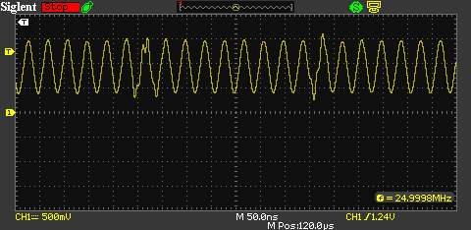

Picture : XI signal with some spikes

In XI signal we can se some distortion.

Broken device

XO measured on C41:

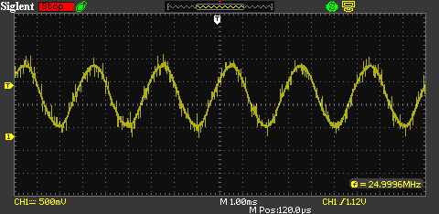

Picture : XO

XI measured on C42:

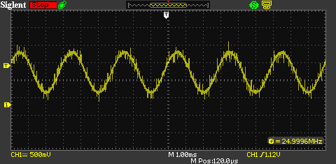

Picture : XI